How to Use the Brightspace Pulse App
- Getting Started
  - Download the Brightspace Pulse App from the App Store.
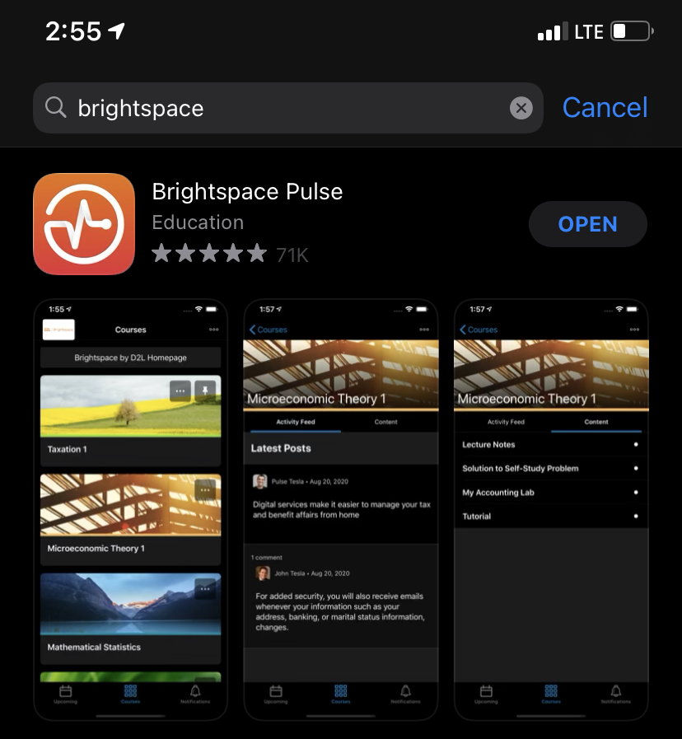
  - Open the app, click the “Get Started” button.

  - When asked: Who provides your learning? Type in the search bar “Brightspace – The University of Akron”.

  - Next, you will type in your UANet ID and Password just like on My Akron.

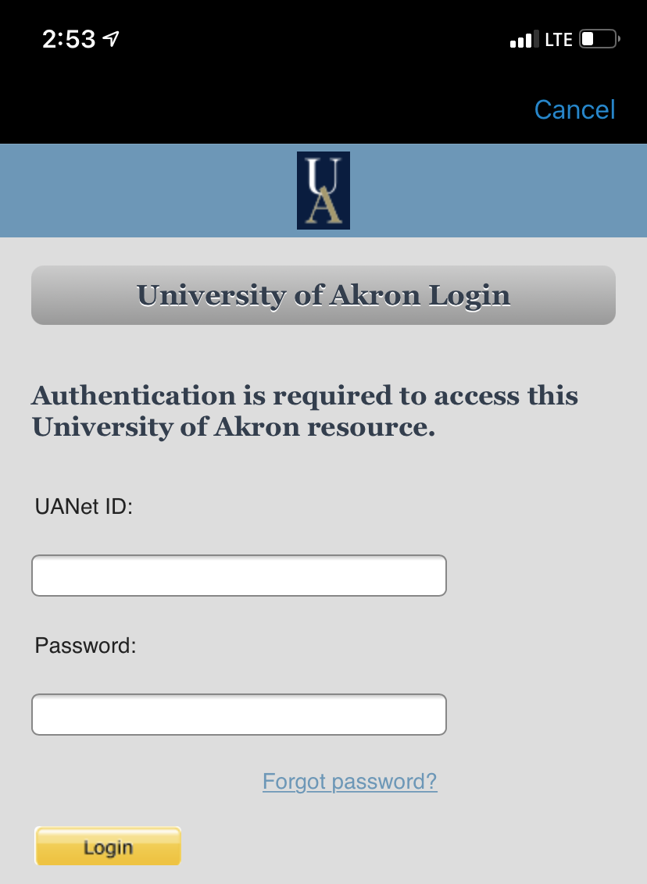

- Using the App
  - At the bottom of the screen there are three tabs: Upcoming, Courses, and Notifications.

  - The tab on the left shows all the important upcoming due dates or exam/quiz dates from what each of your professors put on their course schedules. For December 8th, I only had one final exam for Thermodynamics I.

  - The middle tab lists all your current Courses.
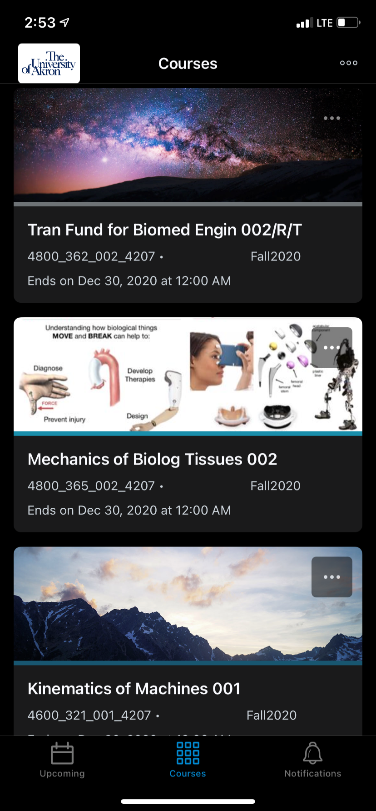

    - If you click on one of your courses, the information that your professor has on their homepage is what you will see. If you want to look at assignments, grades or other material that you cannot see on this screen, click the three dots in the top right-hand corner of your screen.

  - The tab on the right shows all the Brightspace Notifications for when grades are put in, announcements are made, or new content is posted by your professor.

    - Clicking on an updated grade notification will reveal the grade you received. If you want to view the grade online for further detail or possibly feedback from your professor, click “View Grade” at the bottom.
